**Example:** [**(Simplified)**](https://developer.ibm.com/patterns/visualize-unstructured-text/)

Project Design Phase-II

Data Flow Diagram & User Stories

|  |  |
| --- | --- |
| Date | 19 October 2022 |
| Team ID | PNT2022TMID49907 |
| Project Name | News Tracker Application |
| Maximum Marks | 4 Marks |



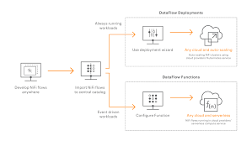 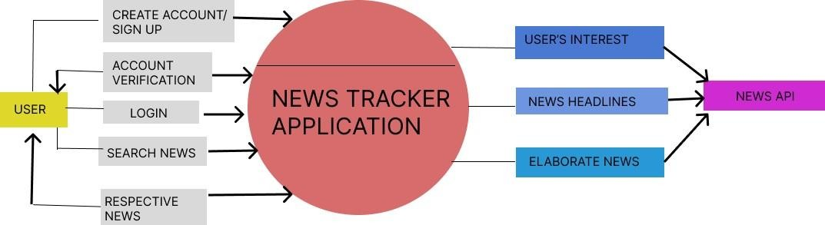

Connect to any data source anywhere, process, and deliver to any destination

**User Stories**

|  |  |  |  |  |
| --- | --- | --- | --- | --- |
| **User Type** | **Functional Requirement (Epic)** | **User Story Number** | **User Story / Task** | **Acceptance criteria** |
| Customer (Mobile user) | Registration | USN-1 | As a user, I can register for the application by entering my email, password, and confirming my password. | I can access my account / dashboard |
|  |  | USN-2 | As a user, I will receive confirmation email once I have registered for the application | I can receive confirmation email & click confirm |
|  |  | USN-4 | As a user, I can register for the application through Gmail | I can receive password to mail. |
|  | Login | USN-5 | As a user, I can log into the application by entering email & password | I can receive confirmation mail. |
|  | Dashboard | USN-6 | The news portal and shows the recent  news as Breaking NEWS | I can Open and view the  news portal. |
| Customer (Web user) | Search Bar | USN-7 | User searches for news based on their own interest. | I can view the related news and can watch videos. |
|  |  | USN-8 | The news can be viewed that is appearing on the dashboard. | On the dashboard.  I shall click on the news  wanted and can open it. |
| Administrator | Server | USN-9 | Provides correct news available from the database. | Provide the correct news from the database and fake  news will be rejected |
|  |  | USN-10 | Provide live news with video and audio contents. | I can get the news in which I am interested. |